Sales Performance Dashboard
Documentation — Power BI dashboard sourced from Snowflake

1. Objective
The dashboard reports sales performance in Microsoft Power BI using data stored in Snowflake. It brings the main sales measures onto one page so that revenue, orders, customers and average order value can be checked quickly and then explored by category, month, region, product and sales channel.
The work covered in this document is:
- Setting up the Snowflake warehouse, database and schema for the sales data.
- Creating the sales tables, loading the CSV files and validating the row counts.
- Creating views with readable names and giving Power BI access to them.
- Connecting Power BI to Snowflake and loading the four views.
- Creating the KPI measures and building the dashboard page with charts and slicers.

2. Snowflake setup
The Snowflake objects were created with the ACCOUNTADMIN role. The warehouse is X-Small, with auto-suspend set to 60 seconds and auto-resume on. The result panel confirms the session was using database RETAIL_DB_ARYAN, schema SALES_DASH_ARYAN and warehouse RETAIL_WH_ARYAN.
Object | Name | Details
Warehouse | RETAIL_WH_ARYAN | X-Small, auto-suspend 60s, auto-resume on
Database | RETAIL_DB_ARYAN | Created if not exists
Schema | SALES_DASH_ARYAN | Schema used for all sales tables and views
Role used | ACCOUNTADMIN | Role active in the worksheets

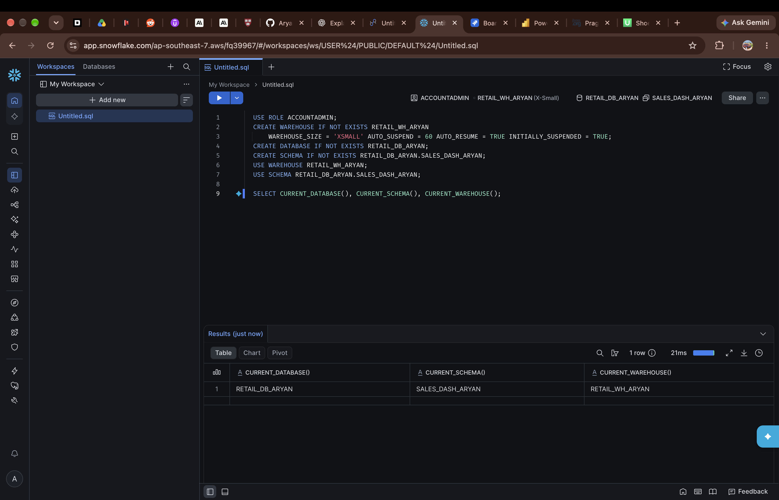
Figure 1 — Warehouse, database and schema created; current database, schema and warehouse confirmed.

3. Tables created in Snowflake
Four tables hold the sales data in the SALES_DASH_ARYAN schema: one fact table and three dimension tables. The screenshots below show the create statements for the date dimension, the product dimension and the sales fact table.
Table | Contents shown in the screenshots
DIM_DATE_ARYAN | Calendar date, year, quarter, month number, month name, month short, year-month, week of year, day of week and weekend flag
DIM_PRODUCT_ARYAN | Product ID, product name, category, sub-category and list price
FACT_SALES_ARYAN | Order line ID, order ID, order date, customer ID, product ID, quantity, unit price, discount percentage, revenue and sales channel
DIM_CUSTOMER_ARYAN | Customer dimension; its loaded row count is shown in the validation check in Section 5

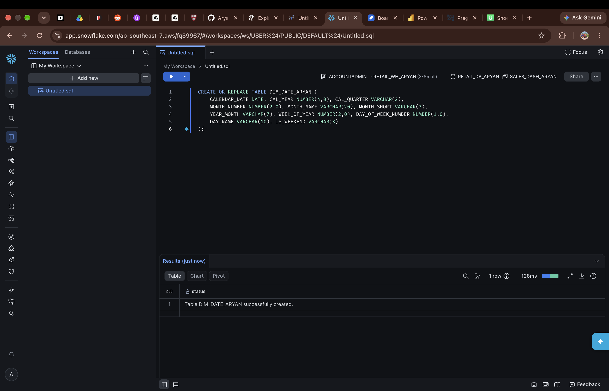
Figure 2 — DIM_DATE_ARYAN table created.
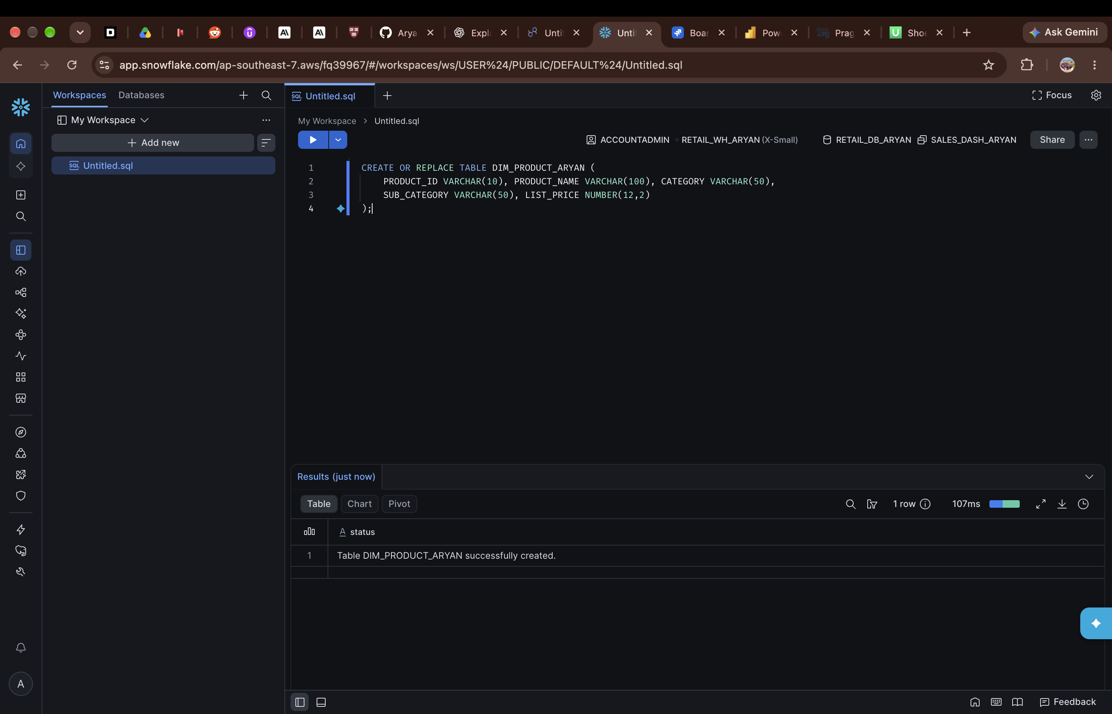
Figure 3 — DIM_PRODUCT_ARYAN table created.
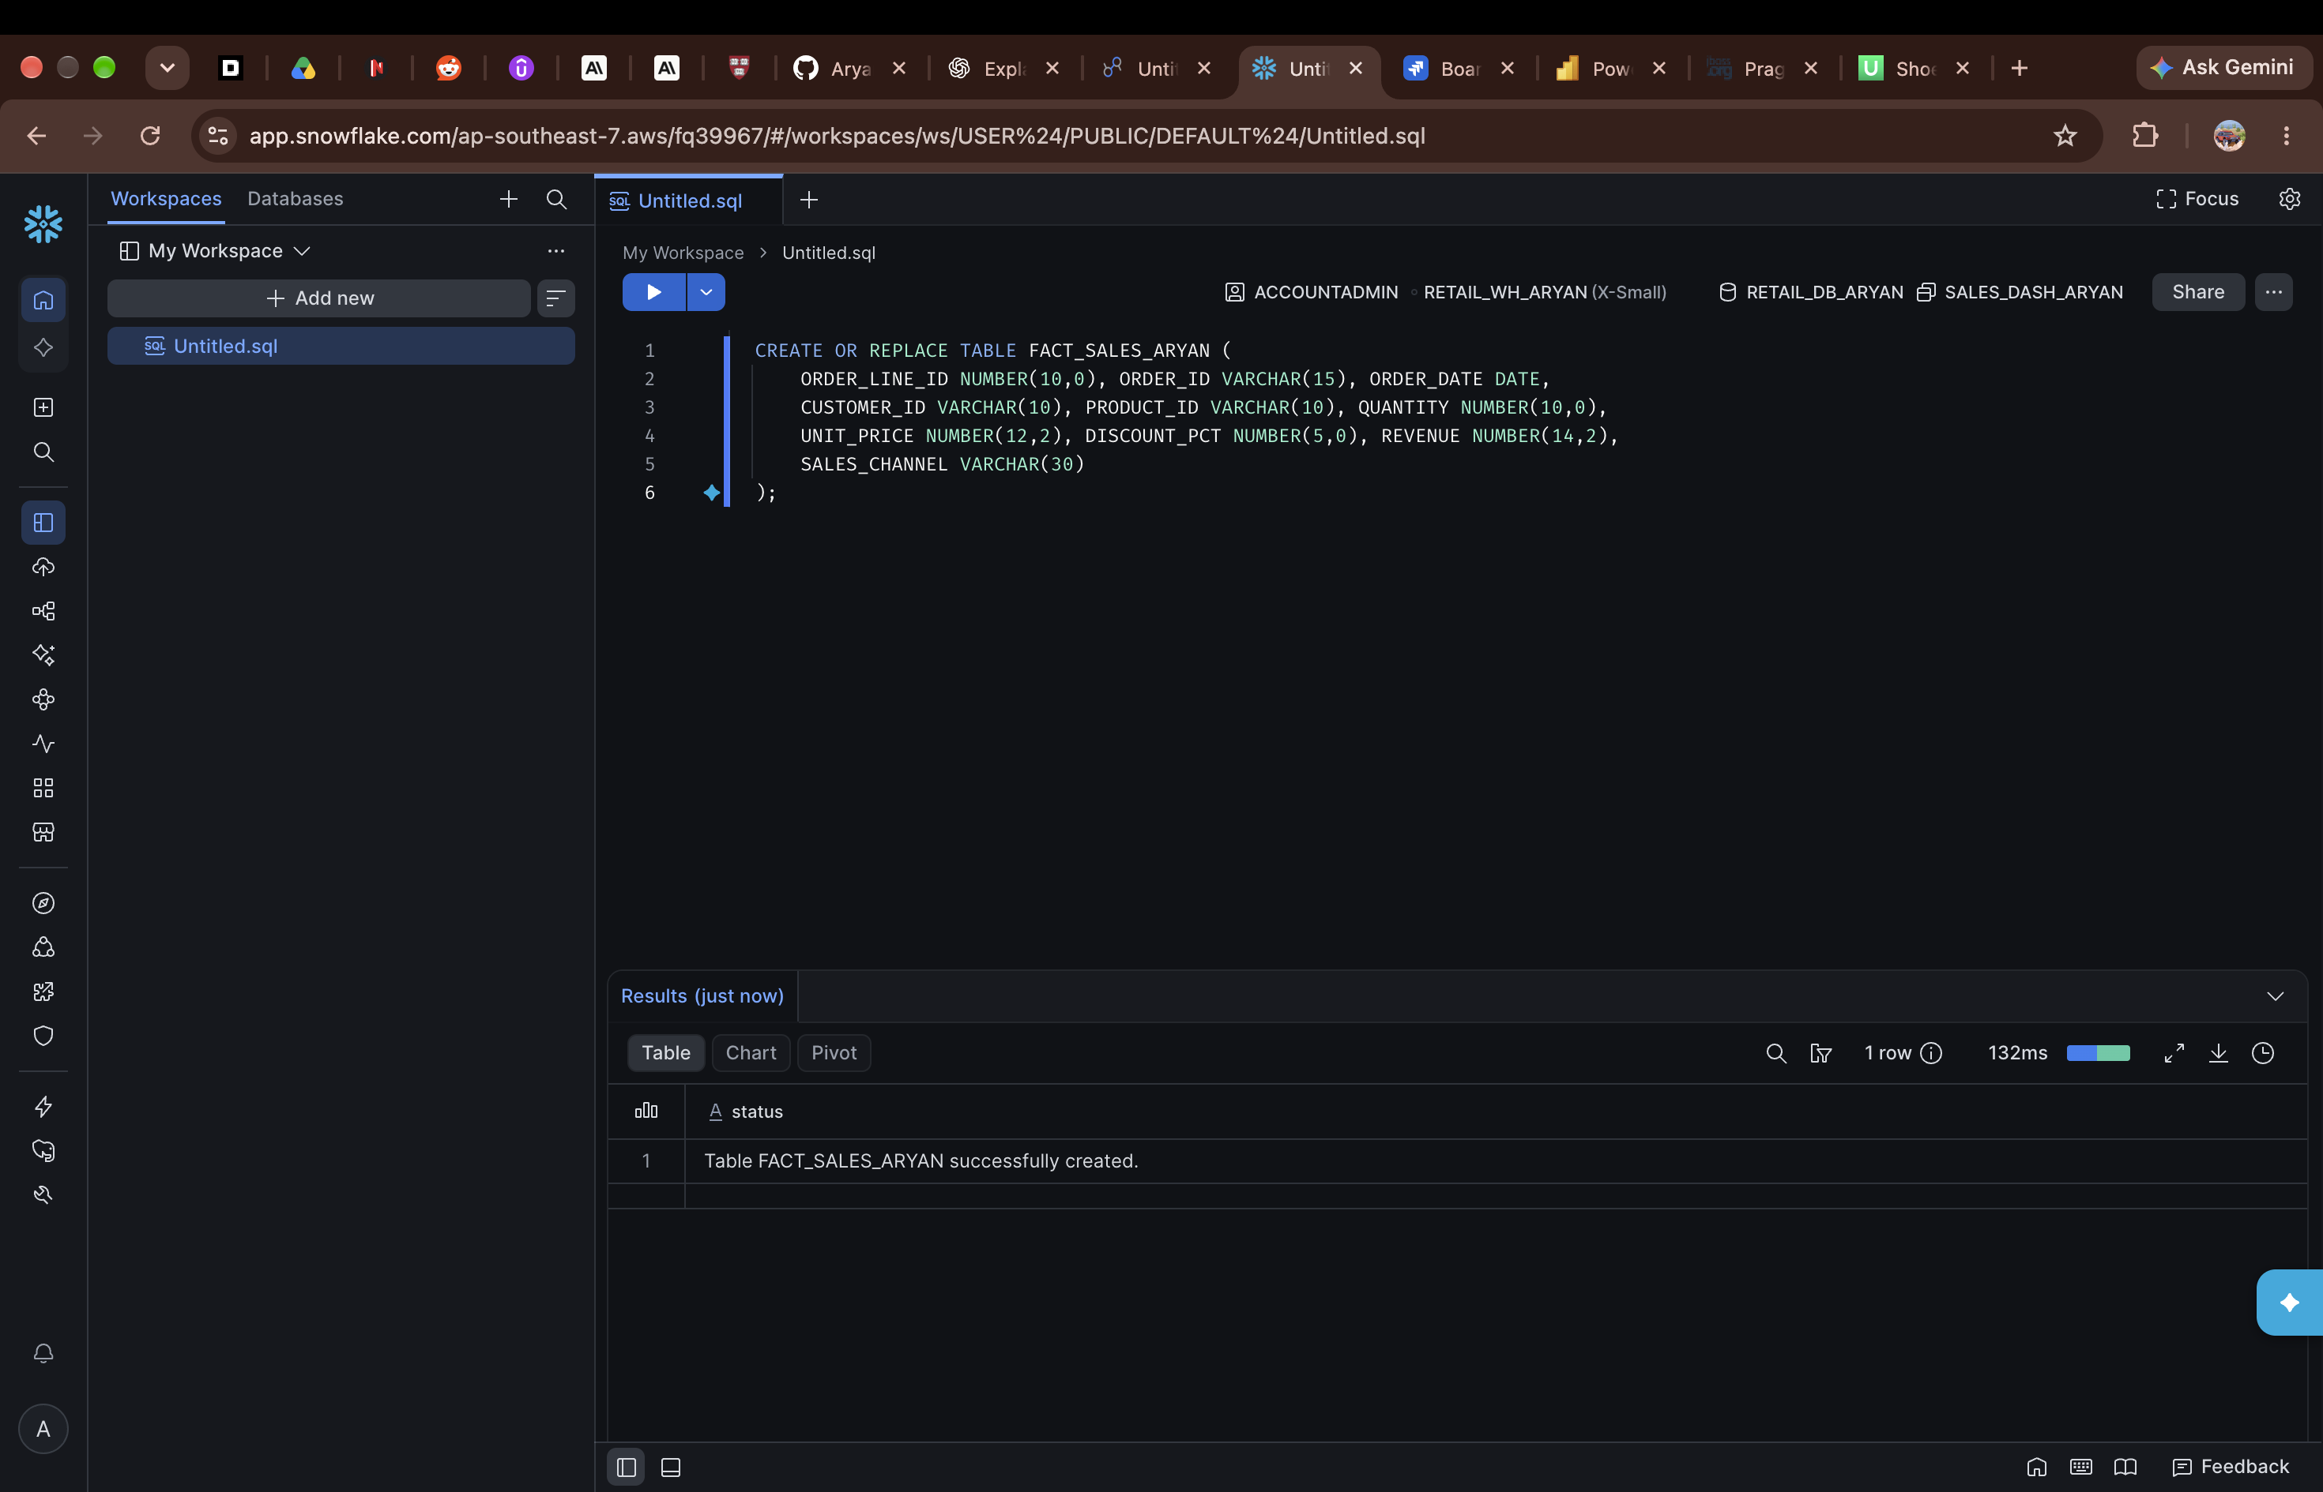
Figure 4 — FACT_SALES_ARYAN table created.

4. Stage and data load
A CSV file format and an internal stage were created for the load. The file format skips the header row and treats empty fields as null. Four CSV files were uploaded to the stage, and the data was loaded into the tables with COPY INTO. The load result for the sales fact table shows status LOADED, with 4,531 rows parsed and 4,531 rows loaded and no errors.
File in stage | Size (bytes)
sales_dim_customer.csv | 12,832
sales_dim_date.csv | 20,800
sales_dim_product.csv | 912
sales_fact.csv | 295,280

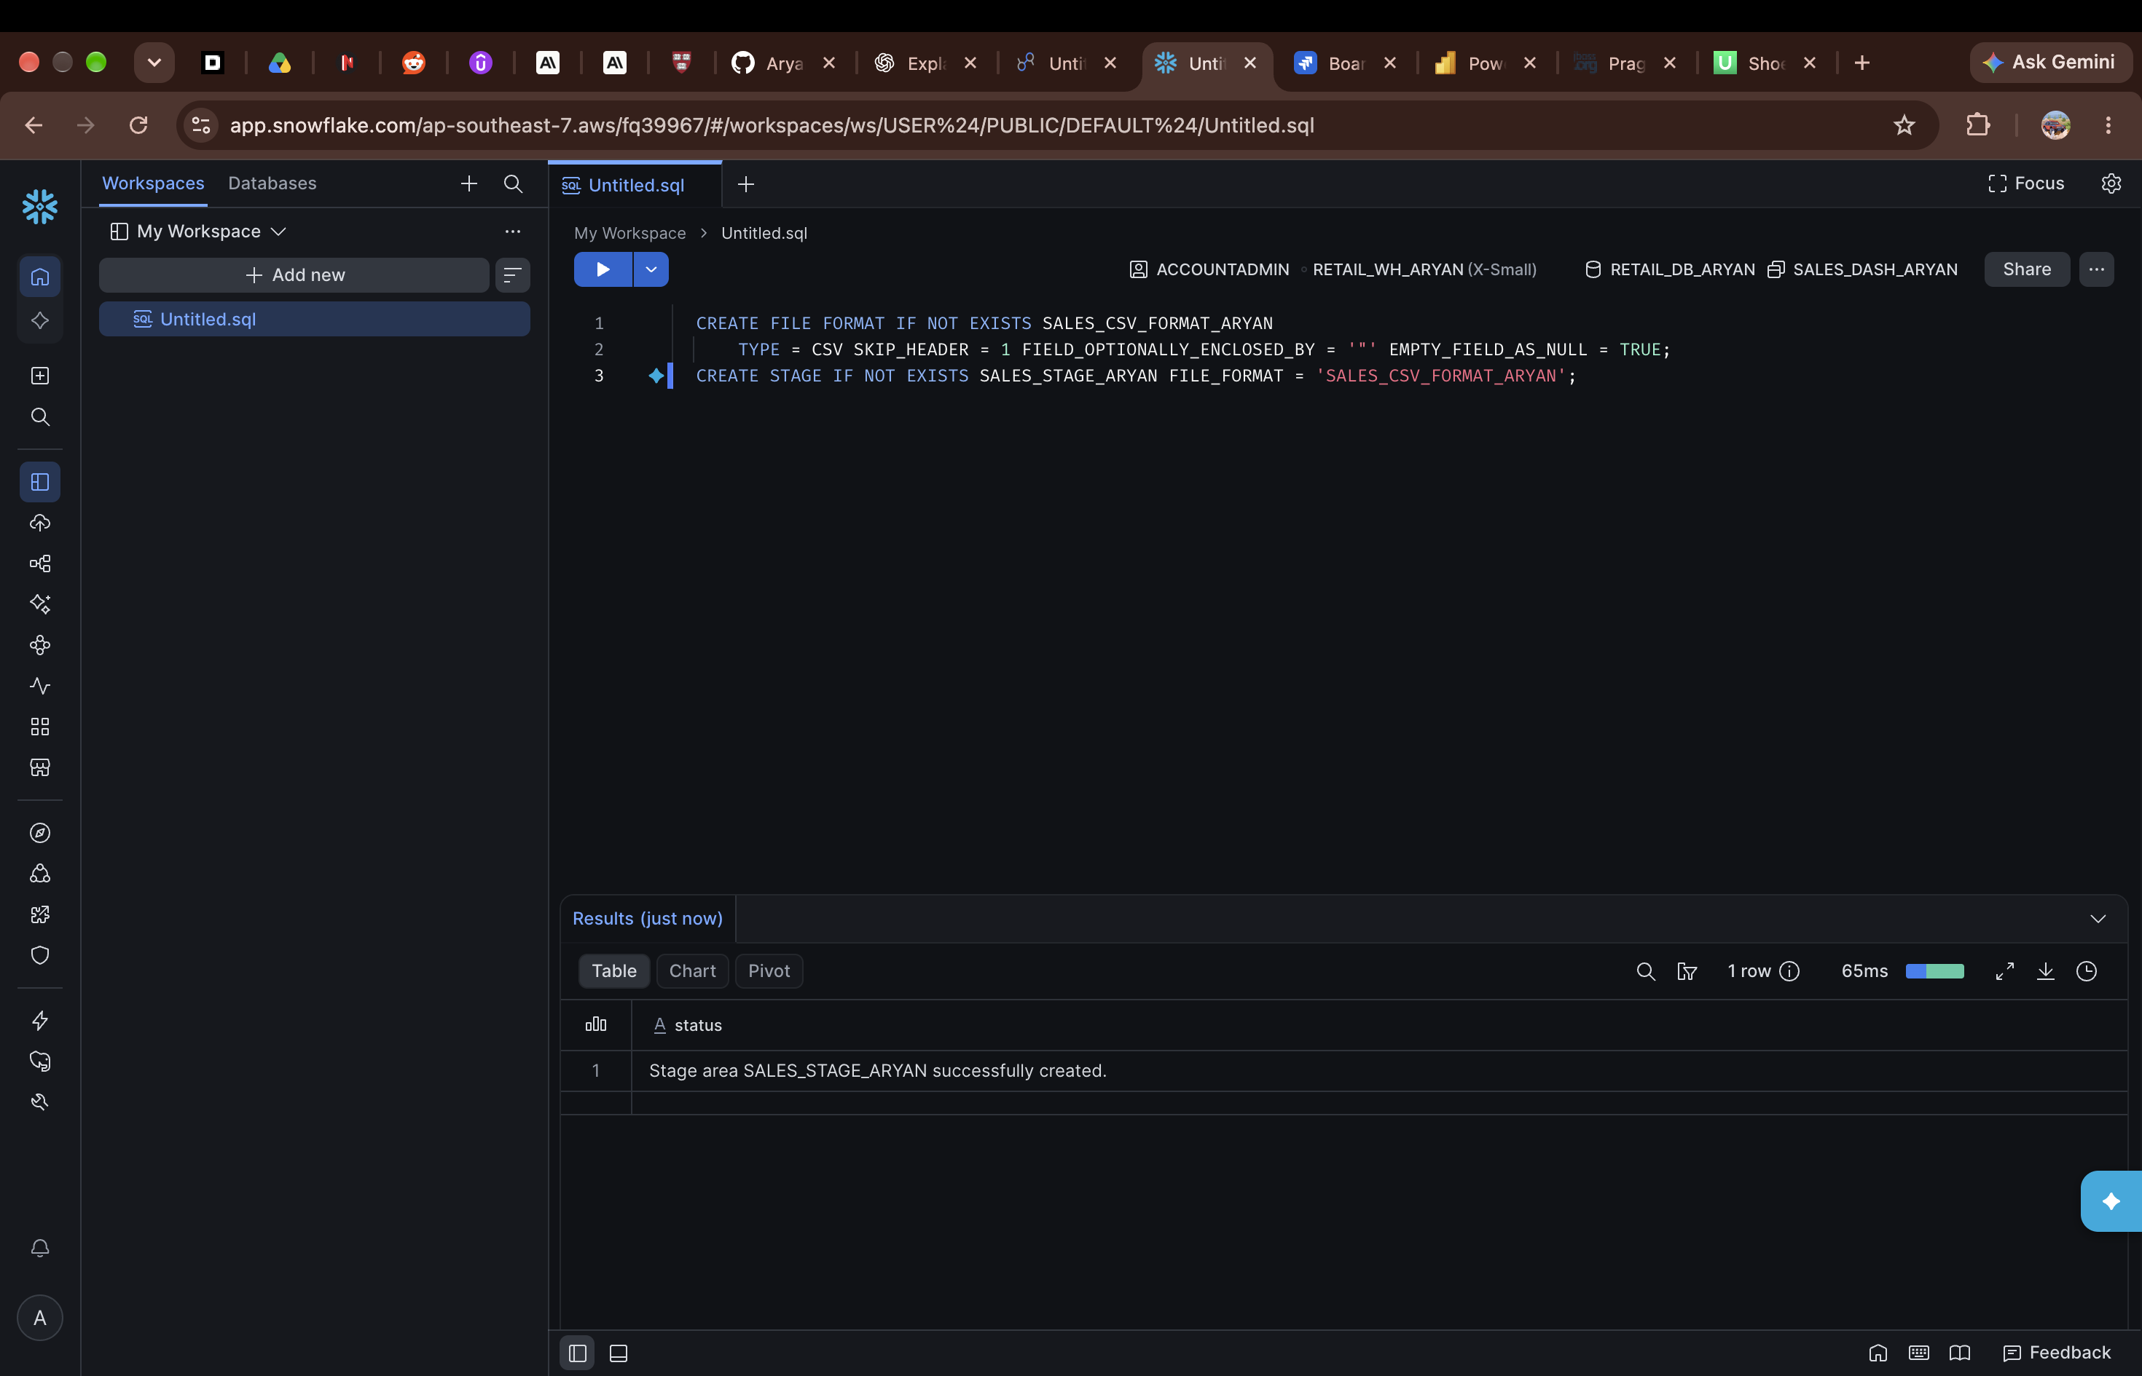
Figure 5 — File format SALES_CSV_FORMAT_ARYAN and stage SALES_STAGE_ARYAN created.
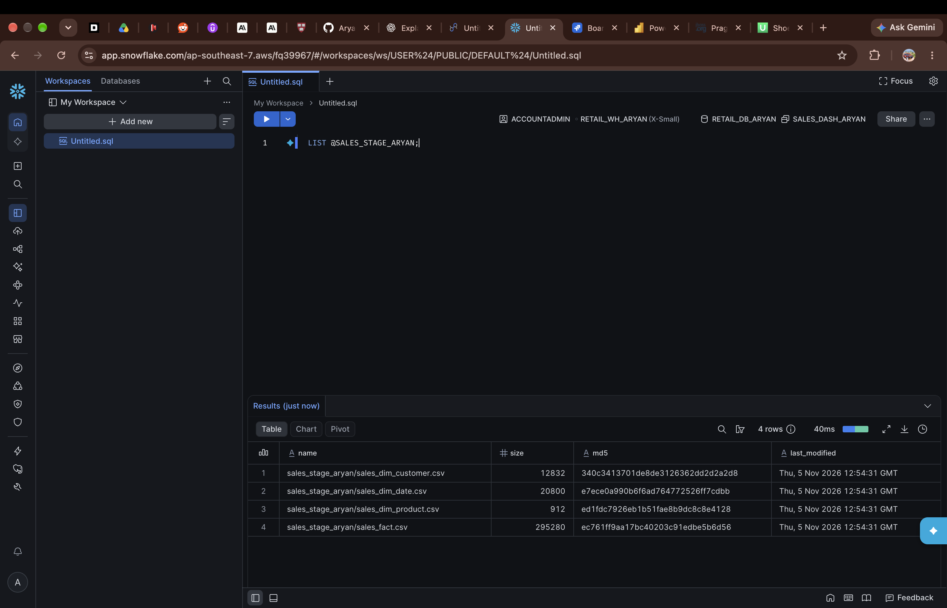
Figure 6 — LIST @SALES_STAGE_ARYAN showing the four uploaded CSV files.
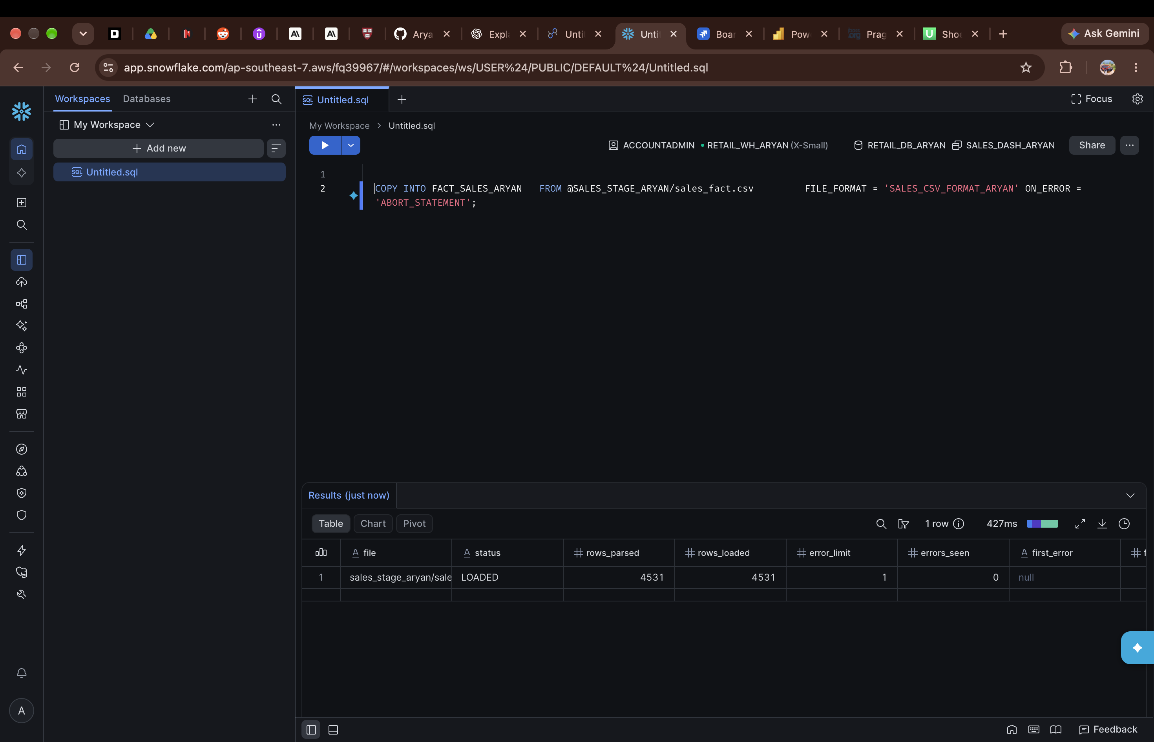
Figure 7 — COPY INTO FACT_SALES_ARYAN: 4,531 rows loaded, status LOADED.

5. Views, validation and access for Power BI
The loaded tables were checked with a row-count query. The counts match the loaded files, and the sales fact table holds 2,600 distinct orders.
Check | Rows
DIM_DATE | 365
DIM_PRODUCT | 20
DIM_CUSTOMER | 300
FACT_SALES | 4,531
Distinct orders in FACT_SALES | 2,600

Four views were then created over the tables so that Power BI receives short table names and readable column names, for example Order ID, Customer Name, Category and Revenue. A separate role, POWERBI_ROLE_ARYAN, was created and granted usage on the warehouse, database and schema, select on all views in the schema, and the role was granted to the user.
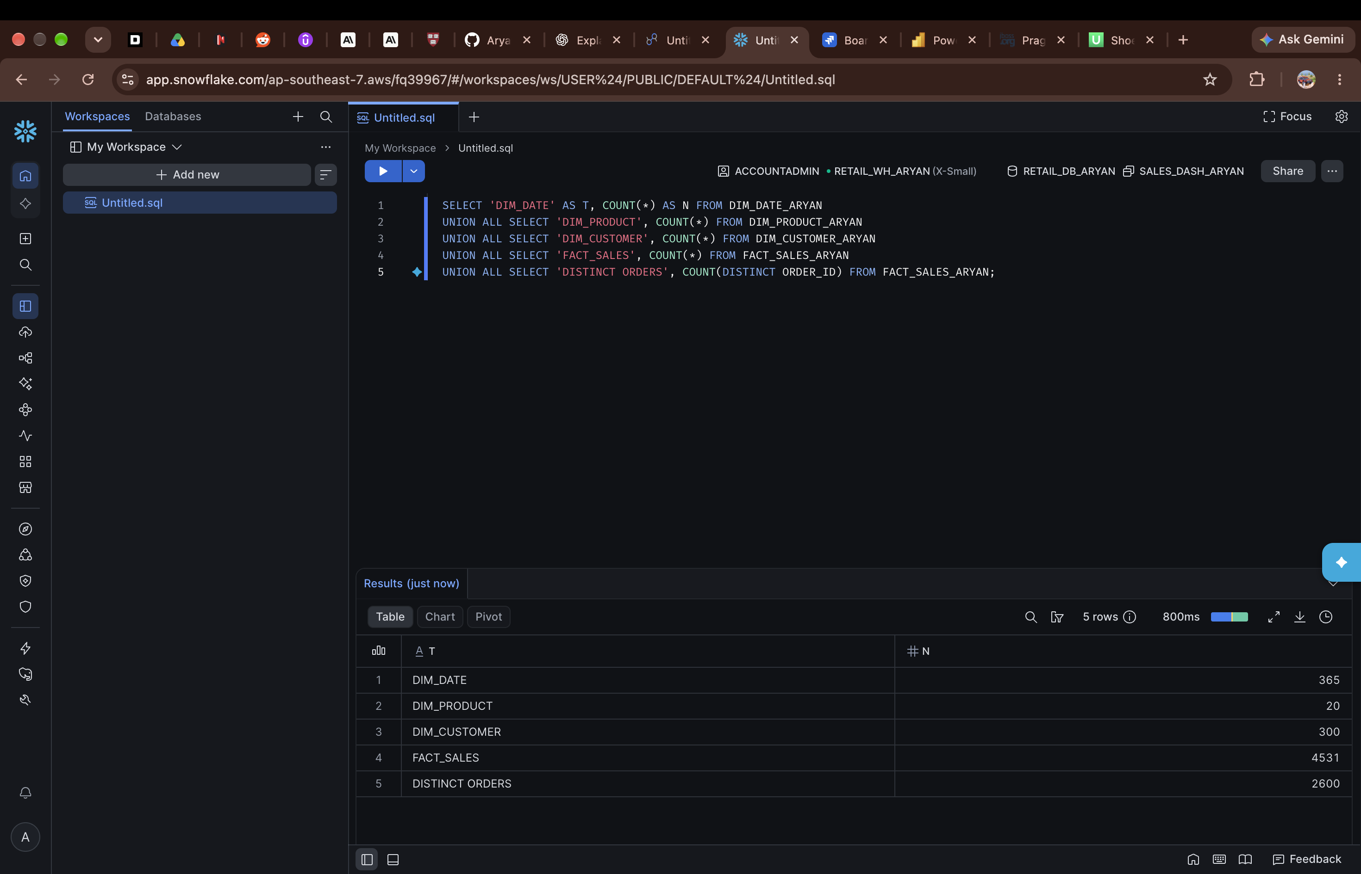
Figure 8 — Validation: row counts for the date, product and customer dimensions, the sales fact table and distinct orders.
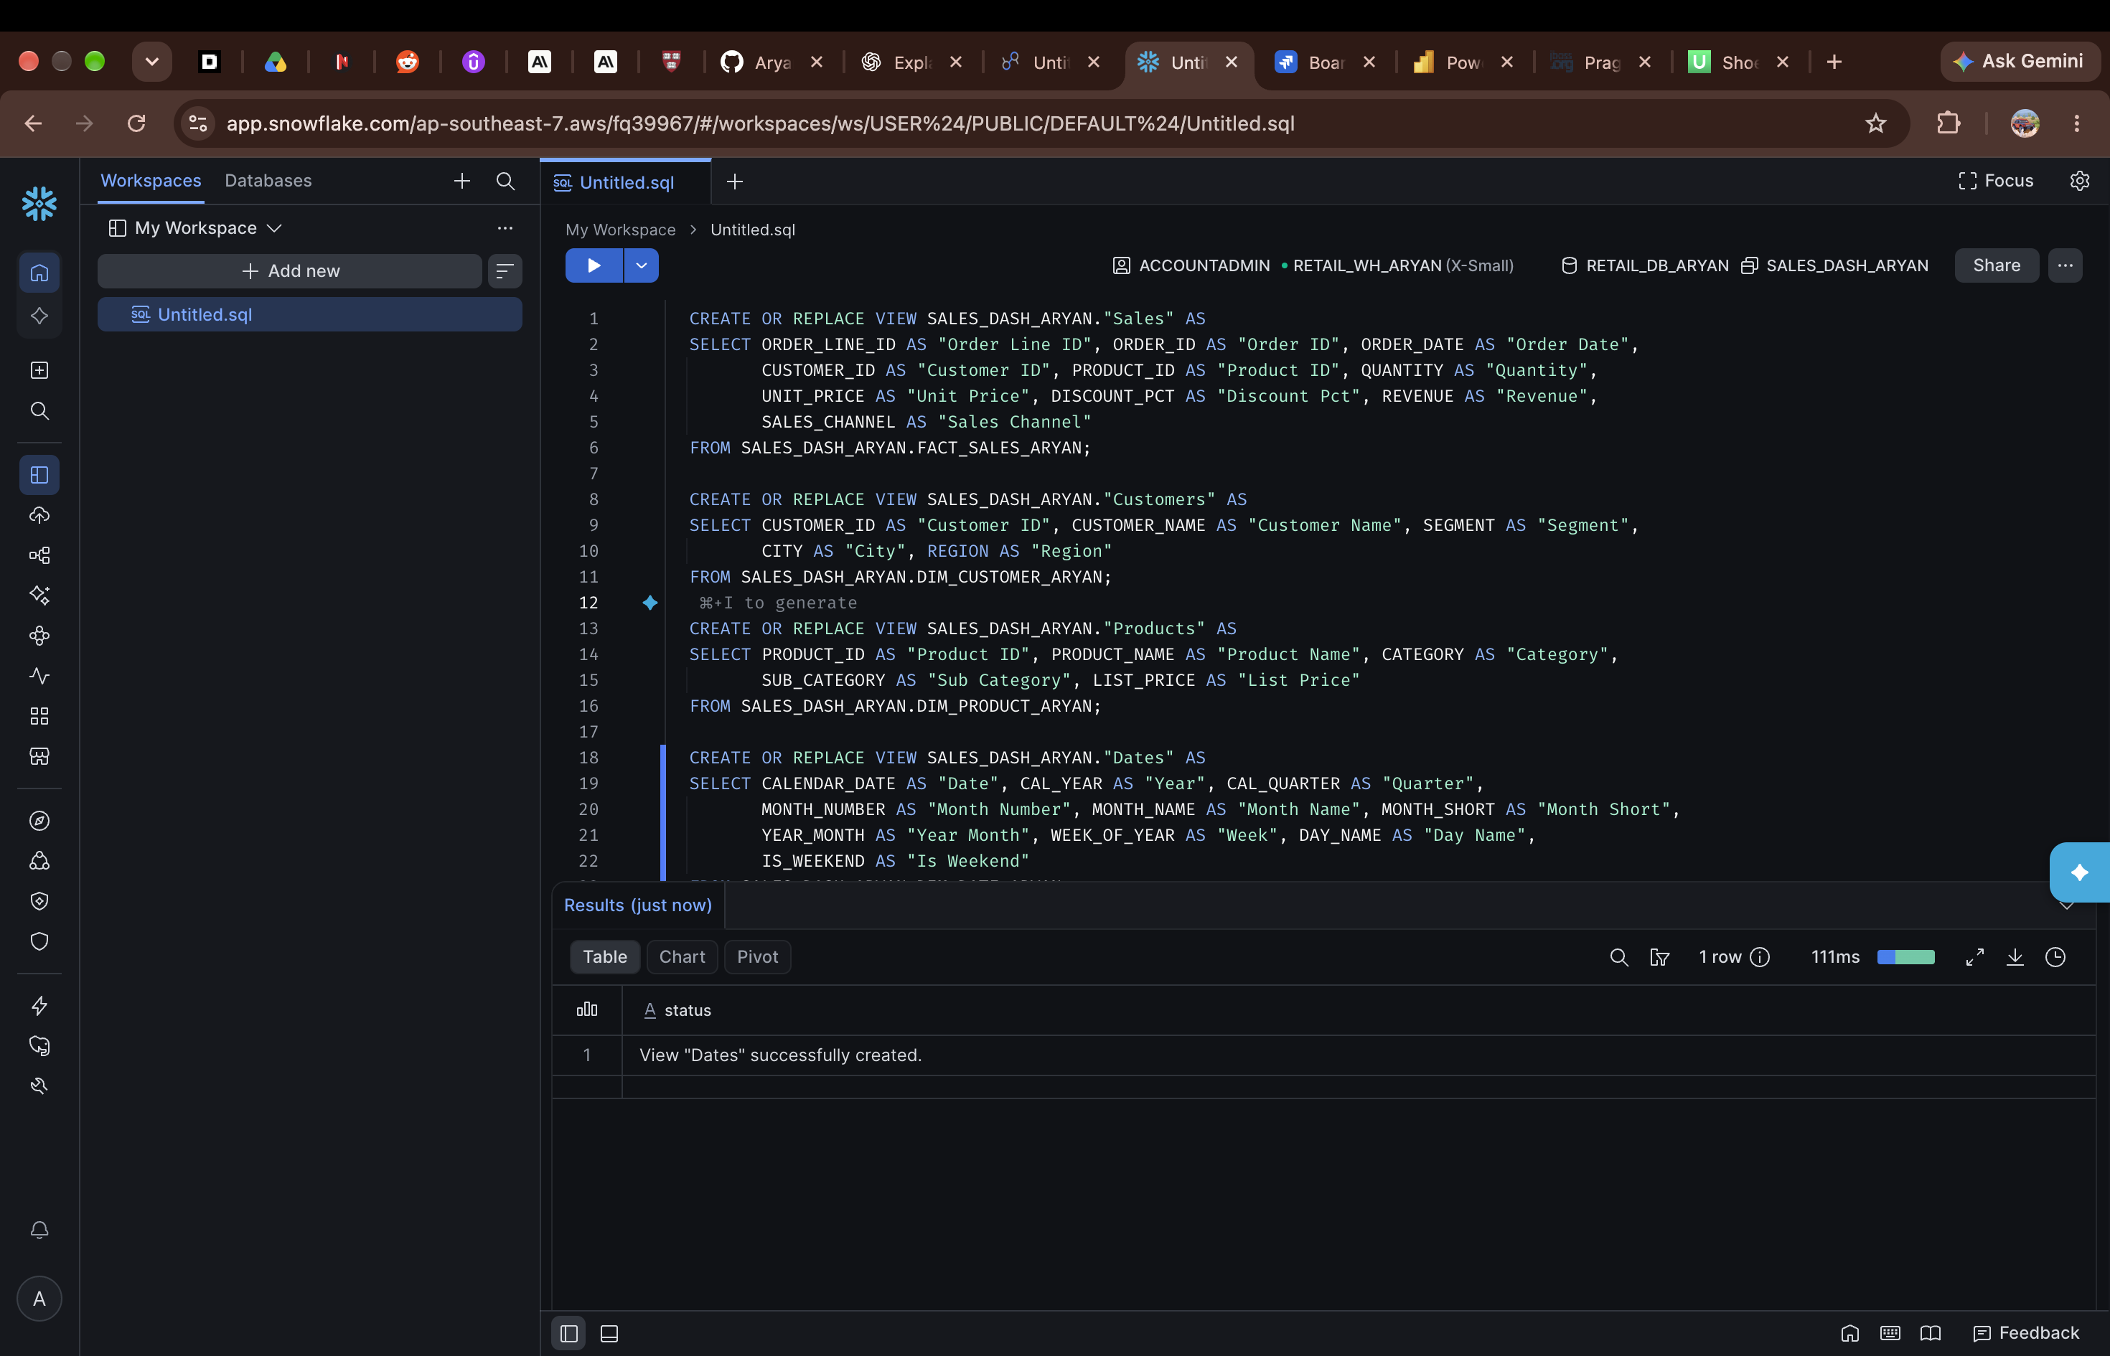
Figure 9 — Views Sales, Customers, Products and Dates created with readable column names.
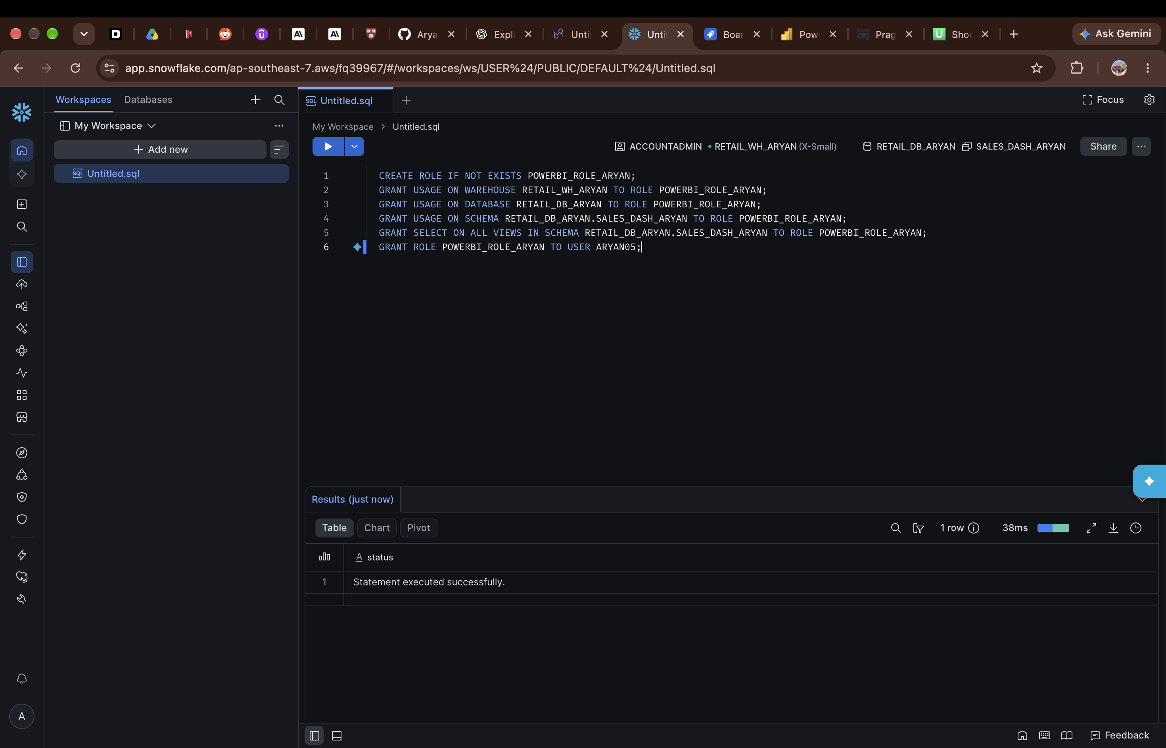
Figure 10 — POWERBI_ROLE_ARYAN created and granted access to the warehouse, schema and views.

6. Connecting Power BI to Snowflake
Power BI was connected to Snowflake using the warehouse RETAIL_WH_ARYAN. In Power BI Online the connection was set up in Power Query with Import as the connectivity mode. In Power BI Desktop the Snowflake sign-in was completed, the four views in the SALES_DASH_ARYAN schema — Customers, Dates, Products and Sales — were selected in the Navigator, and the data was loaded into the model.
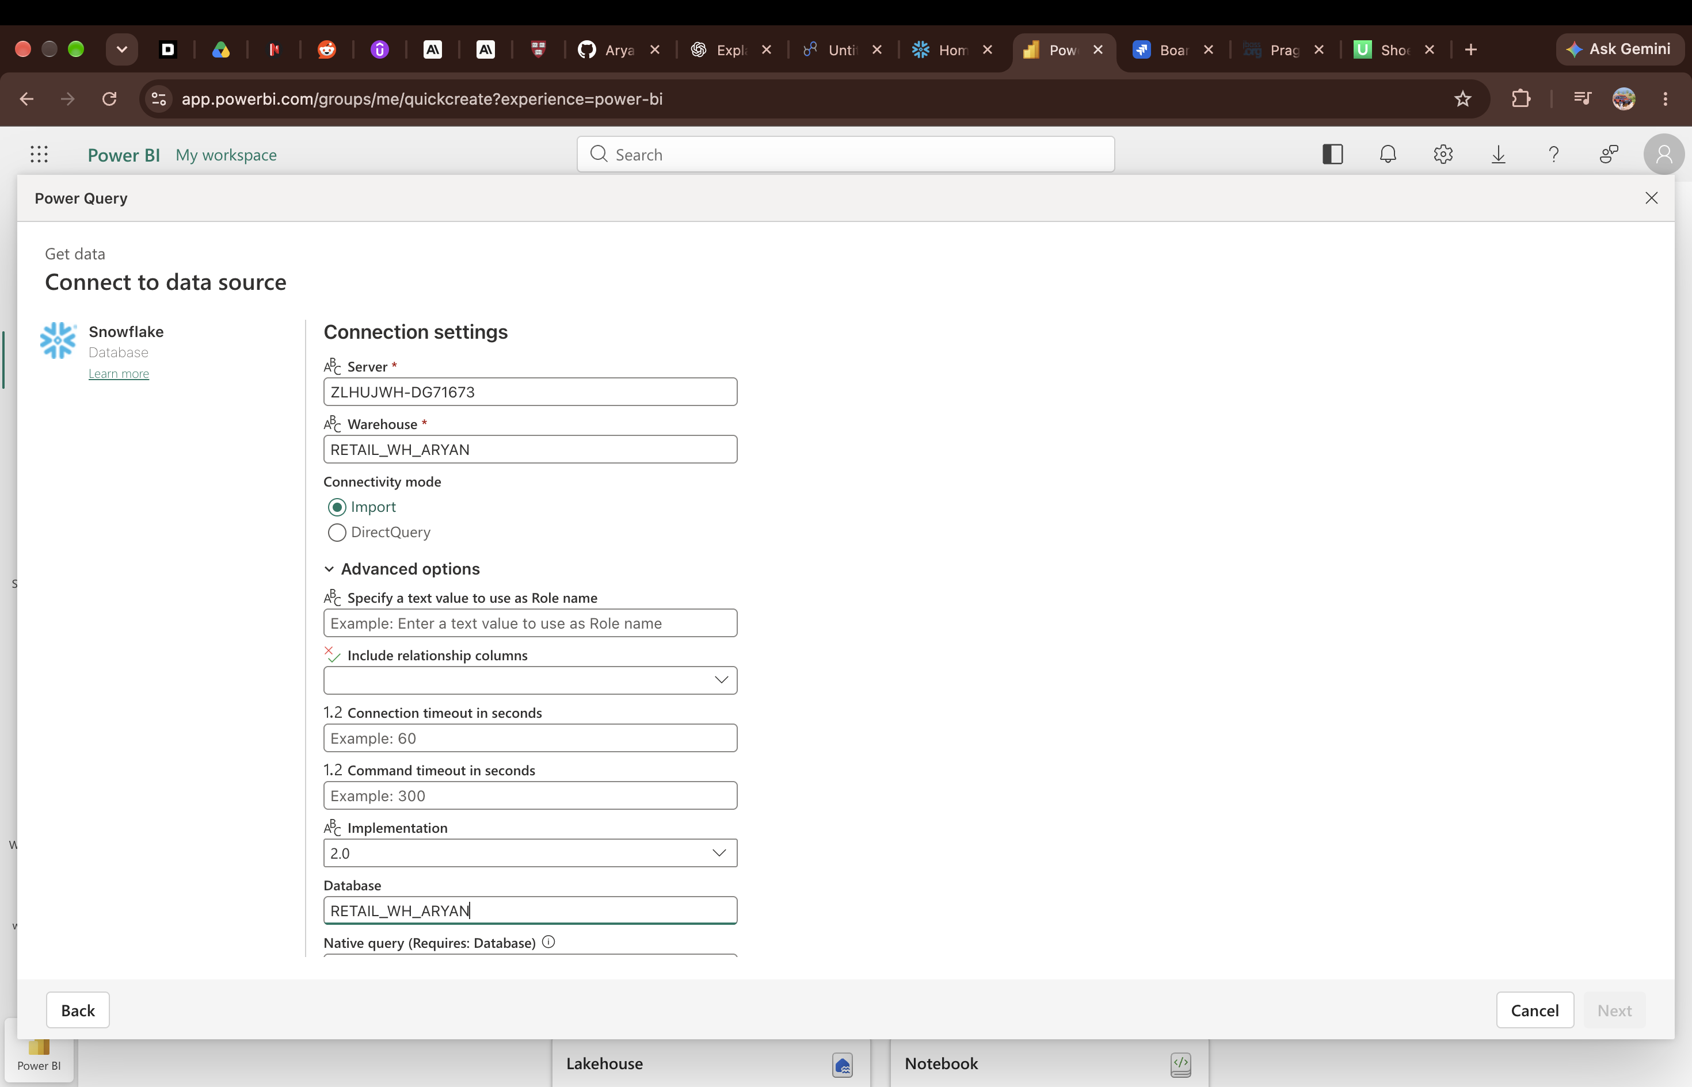
Figure 11 — Snowflake connection settings in Power BI Online: warehouse RETAIL_WH_ARYAN, Import mode.
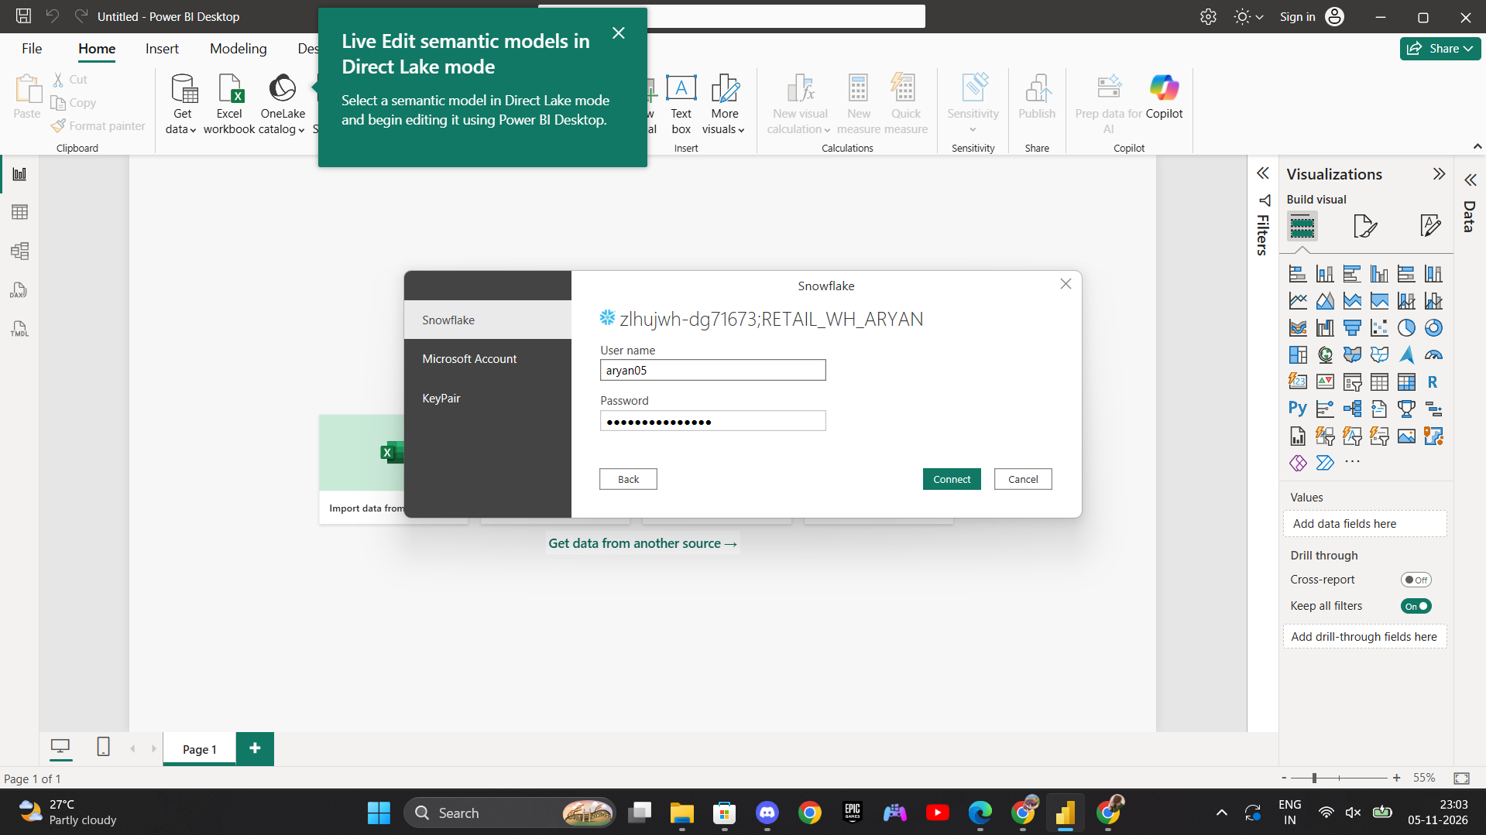
Figure 12 — Snowflake sign-in in Power BI Desktop.
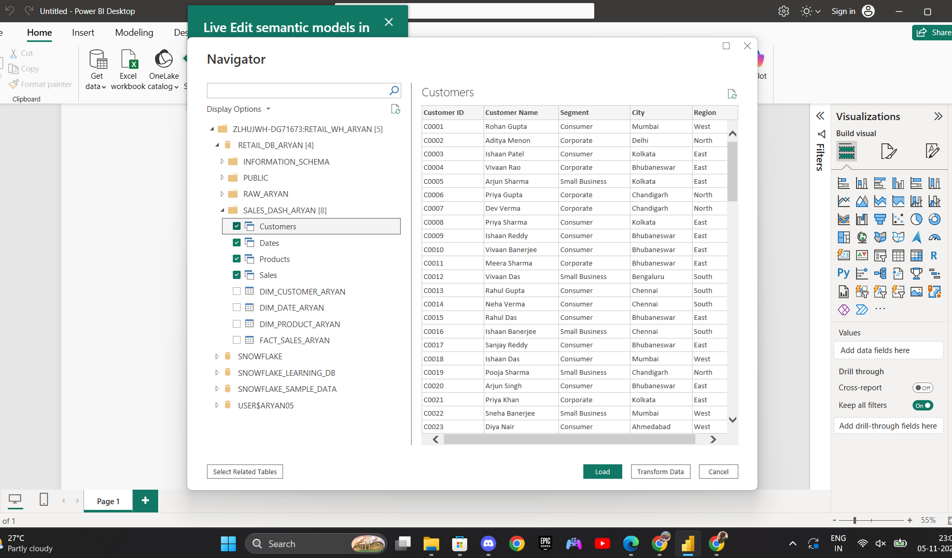
Figure 13 — Navigator: the Customers, Dates, Products and Sales views selected from SALES_DASH_ARYAN in RETAIL_DB_ARYAN.
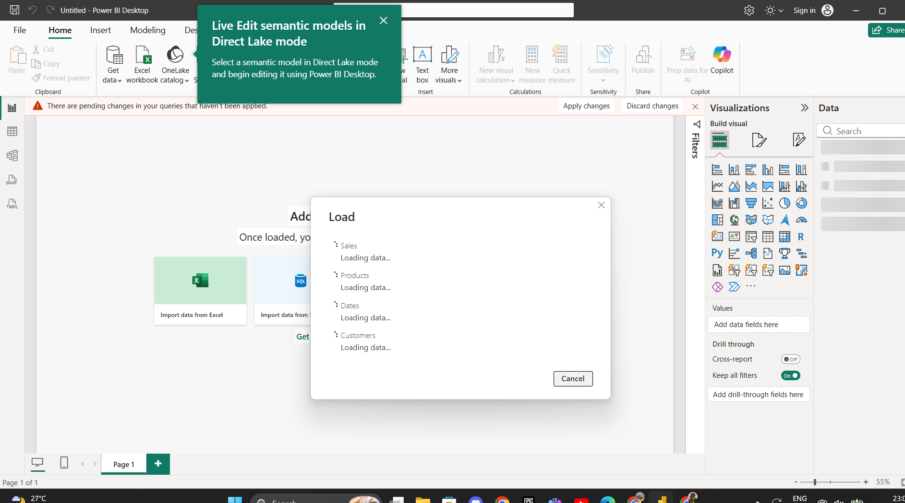
Figure 14 — Loading the Sales, Products, Dates and Customers data into Power BI.

7. KPIs and DAX measures
Four KPI cards sit in a row at the top of the page. The values below are the values shown on the finished dashboard.
KPI | Value shown | Calculation
Total Revenue | 59.45M | Sum of the Revenue column in Sales
Total Orders | 3K | Distinct count of Order ID in Sales. The card rounds the value; the Snowflake check counted 2,600 distinct orders
Total Customers | 252 | DISTINCTCOUNT of Customer ID in Sales
Average Order Value | 22.86K | Total Revenue divided by Total Orders

The Total Customers measure is shown in the formula bar in Figure 15. The Data pane in Figure 16 also shows the supporting measures Total Revenue, Total Orders, Revenue Prev Month and Revenue MoM %, which are used for the month-on-month comparison. The Dates table provides the date fields — Date, Year, Quarter, Month Name, Month Short, Month Number, Week and Is Weekend — used for the monthly trend and the date slicer.
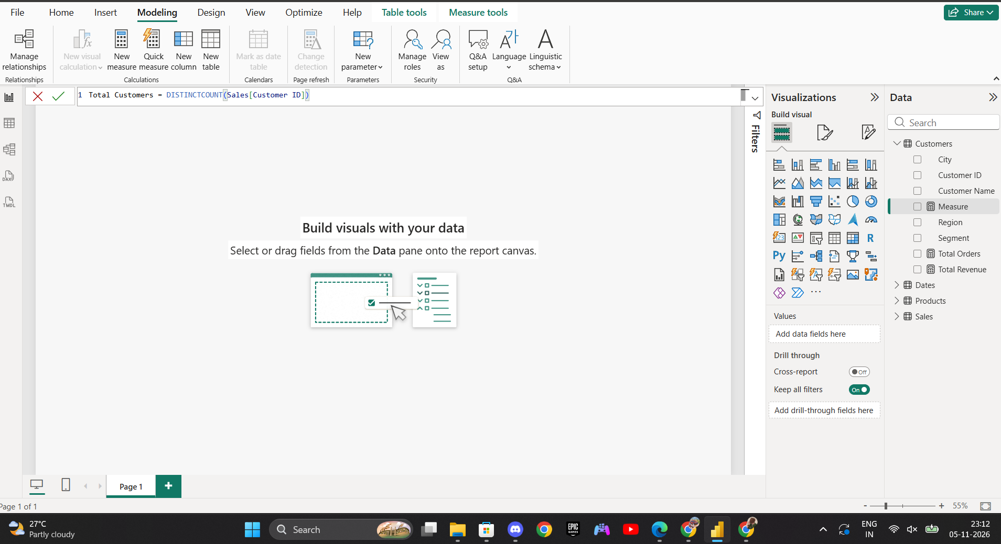
Figure 15 — DAX measure: Total Customers = DISTINCTCOUNT(Sales[Customer ID]).
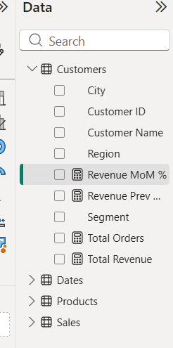
Figure 16 — Data pane detail: measures under Customers, including Revenue MoM %, Revenue Prev Month, Total Orders and Total Revenue.

8. Visuals, slicers and key insights
The finished page, named Sales Performance, uses one layout: KPI cards at the top, charts in the middle and bottom rows, and the slicers grouped in the centre of the page. All visuals respond to the slicers.

Visuals used
Visual | Purpose
Card visuals (4) | Total Revenue, Total Orders, Total Customers and Average Order Value
Line chart — Total Revenue by Month | Monthly revenue trend across the year
Bar chart — Total Revenue by Category | Revenue comparison across the four categories
Donut chart — Total Revenue by Category | Each category's share of total revenue
Column chart — Total Revenue by Region | Revenue comparison across South, West, East and North
Bar chart — Total Revenue by Product Name | Top products by revenue
Combined chart — Total Orders and Average Order Value by Month Short | Order volume and order value together by month

Filters and slicers
- Date — range slider, set to 01-01-2025 to 31-12-2025 in the screenshots.
- Category — Accessories, Electronics, Furniture and Office Supplies.
- Region — East, North, South and West.
- Sales Channel — Online, Partner and Retail Store.

Key insights
- Total revenue is 59.45M from 4,531 sales rows, with an average order value of 22.86K.
- Electronics is the largest category with 31.41M, which is 52.83% of total revenue — just over half of all revenue.
- Furniture contributes 11.49M (19.33%), Office Supplies 10.97M (18.45%) and Accessories 5.58M (9.38%).
- Monthly revenue rises across the year on the line chart, ending the year at its highest level, with a dip around the middle of the year.
- The South region has the highest revenue on the region chart and the North the lowest.
- Laptop is the top product by revenue, followed by Whiteboard and Smartphone.
- 252 distinct customers appear in the sales data, out of 300 customers in the customer dimension.
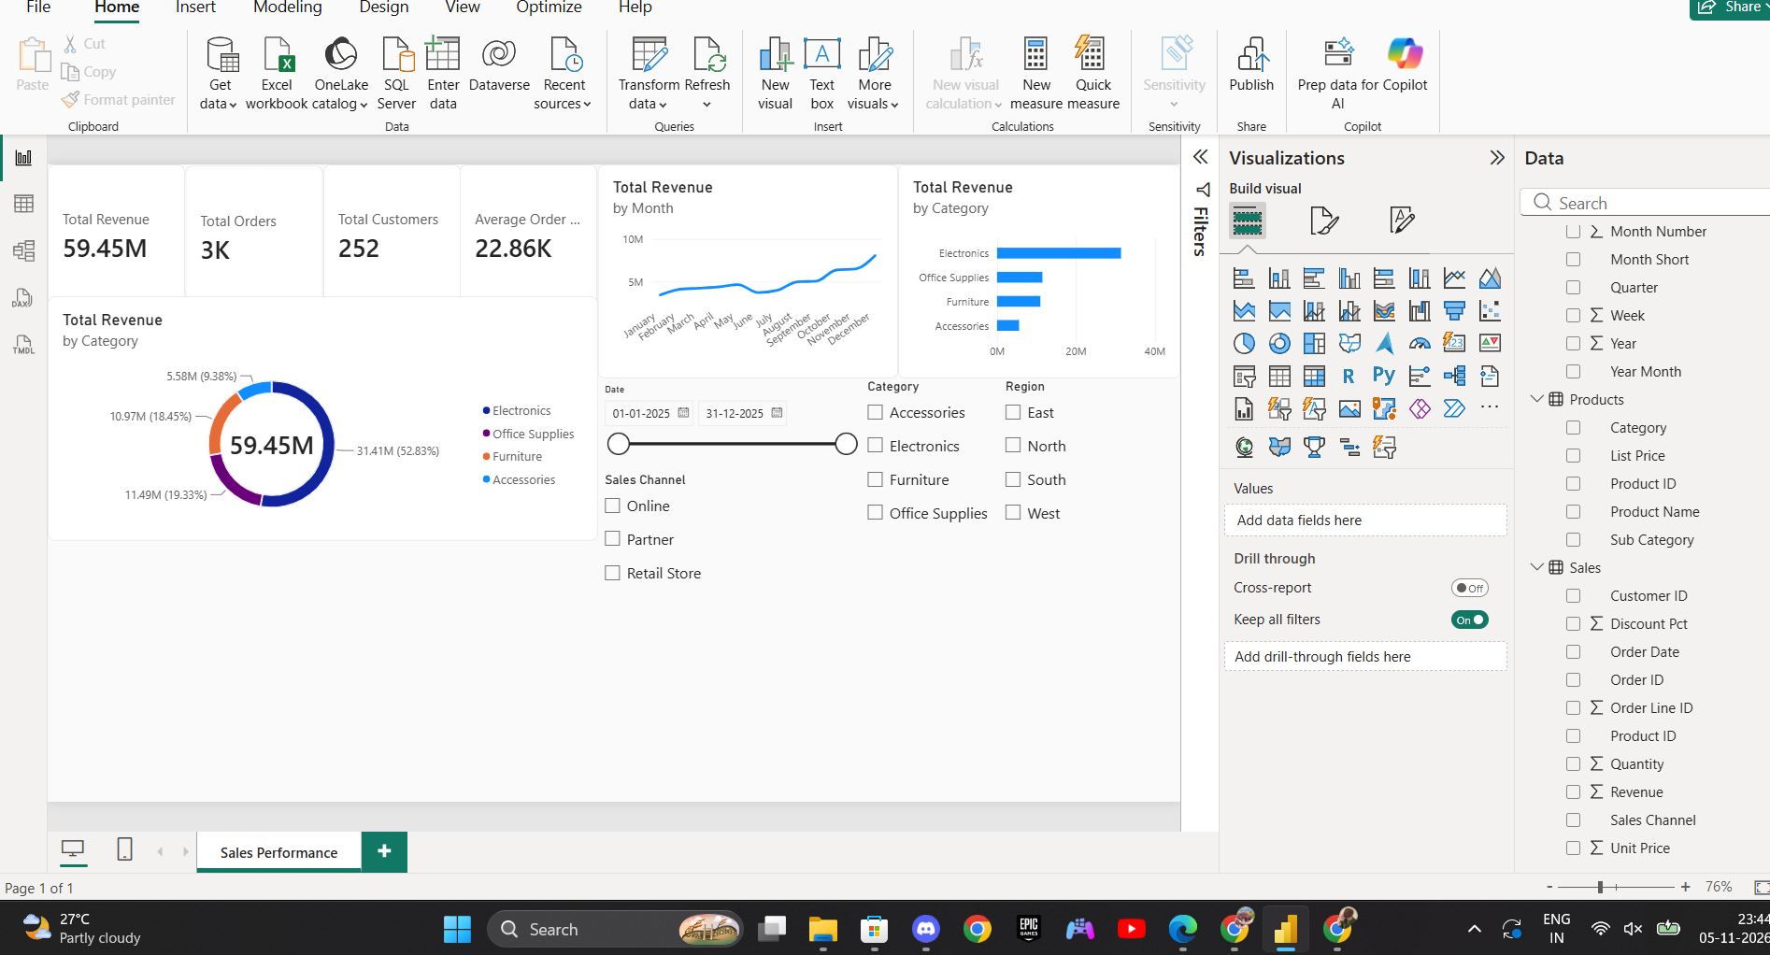
Figure 17 — Dashboard during the build: KPI cards, monthly line chart, category bar chart, category donut chart and the Date, Category, Region and Sales Channel slicers in place.
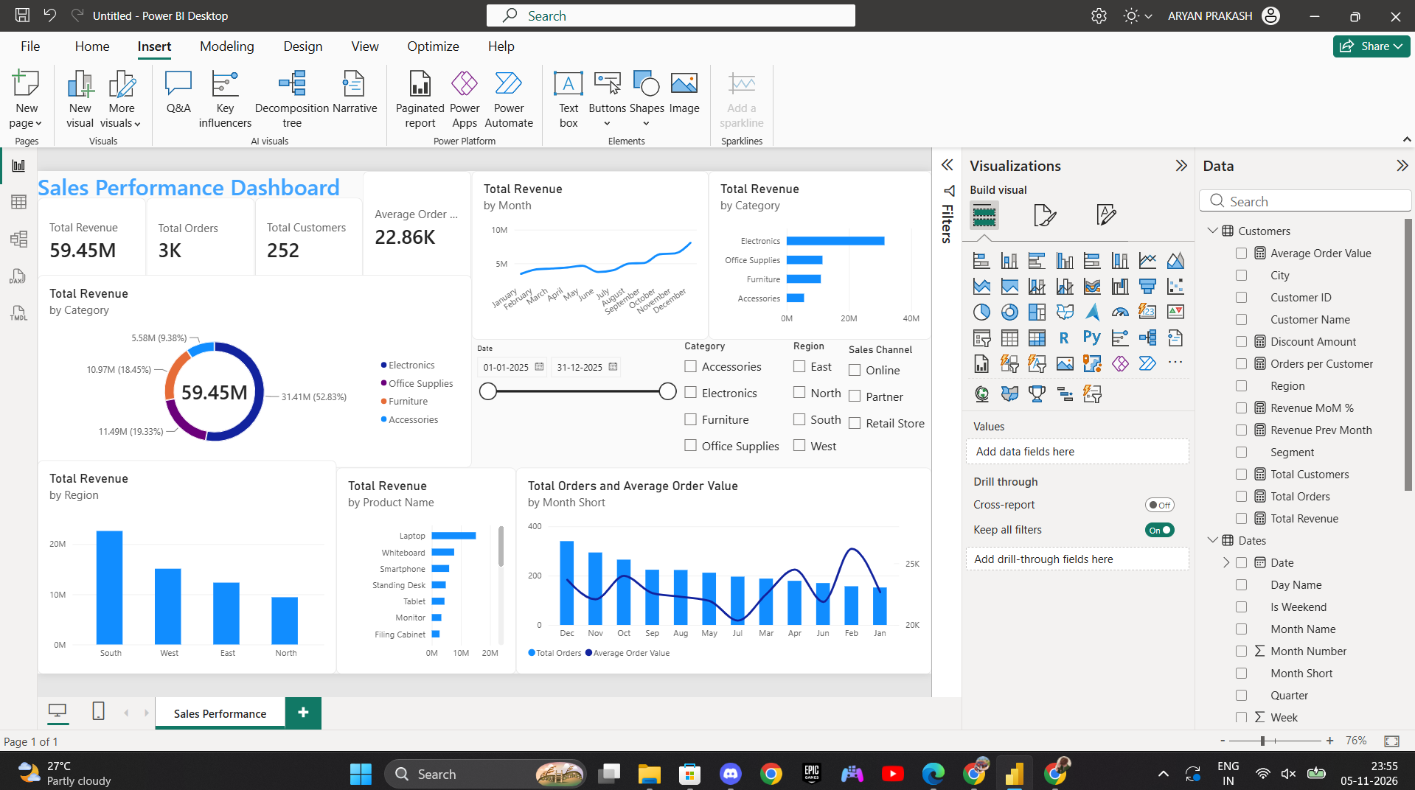
Figure 18 — Finished Sales Performance dashboard page with all visuals and slicers.
The dashboard was built in Power BI Desktop, which is also where the report is saved as a .pbix file, using the Snowflake views as the data source.

